Letter from the Save Clam Falls Flowage Dam people
https://saveclamfallsflowage.com/

The following is from a letter that was created several years ago regarding the fate of the Clam Falls Flowage Dam. I edited it slightly and since it's still relevant today, I decided to post it.
Save the Clam Falls Flowage Dam
Dear neighbors and friends,
We’re sure you have heard many times, in as many years that the 100 plus year old dam’s removal is imminent. However, luckily for all of us, the dam has managed to survive. Recently the conversations have turned more ominous, as the current leaser, Renewable World Energies has indicated it is not cost effective at this time to enable power generation, and they are apparently no longer interested in continuing the lease. This likely will mean that the owner, Northwest Electric, will need to resume direct control of the dam. Because the dam is not producing revenue, removal may be a more likely outcome.
Though the flowage waters retained by the dam are relatively small by the standards of other lakes and flowages, we contend that the impact on our community is great. Setting aside the fact that the dam is an historic reminder of the rich past of this town, the flowage plays an important part in our lives.
For some, it’s a day of boating, tubing, skiing, pulling lunker Bass out of the Lilly pads, hooking a wily Northern, or catching a mess of pan fish to fry. For others, it’s leisurely canoeing or paddle boating around, perhaps to the beaver lodge, and being surprised by its loud tail slap. We’re sure many of you have kids or grandkids that gather by the dam on a hot summer’s day to cool off with a deep refreshing plunge! Perhaps you did that yourself as a child. How many times have you camped on the island, or done a belly flop off of the rope swing?
In the winter, many folks setup icehouses. I hear the fishing is decent, but the beer and comradery is the key, and the short travel time is a bonus! When there’s a good snow cover on the lake, it makes for a great straightaway to open up the snowmobile! Often the snow is cleared for a spirited game of hockey. We even know of a tradition of chipping lake ice for making ice cream!
The recommendation from the board chair at the meeting was to take this to a board committee level for next steps.
We understand there is a meeting this Wed. 4-10 at 9 am and to follow up the next day on Thursday 4-11 to continue the discernment of the fate of the dam. Please attend if you are able. We need your voice and representation This meeting is to discuss the current offer from the Northwestern Power:
A) their offer is for $650,000 plus an additional amount of money up to $55,000 for the third-party structural engineers report to determine the needed repair on the dam to bring it up to top over and DNR exemption status.
Both to be paid by the power company.
B)Any repair costs associated with bringing the dam up to a structurally acceptable level will come out of the $650,000 amount being gifted by the power company.
C) the meeting is to determine what the actual offer is from the power company and what if, any counter offer is to be presented next month including whether the power company will be willing to go ahead with the structural report prior to the county taking ownership of the dam.
D) The county supervisors are unwilling at this time to make a determination until a true valuation of the needed repairs is established and that amount is reduced from the $650,000. If there is not a substantial amount of funds remaining, the county will not except the proposal and the dam will move to removal status.
E) The county supervisors believe that no decisions will be made on the current/final proposal until at the earliest this mid-summer. They also believe that the abandonment paperwork is probably prepared and ready for filing by the power companies if a decision to decline is reached.
Lastly, we are starting a lake association around the flowage to help unify us as a community
and a unified platform to speak from protecting the area.
Please respond to this email if you are interested in being a part of the association.
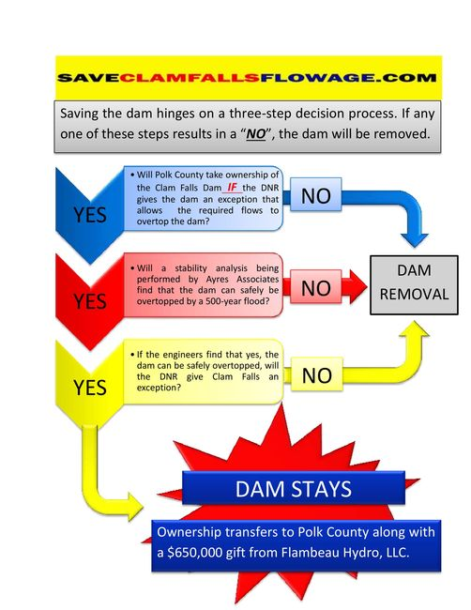

To Craig Roberts, WDNR - This is what someone said about the Clam Falls Dam removal. Can you tell me if it makes sense?”

"You might want to consider clam lakers paying attention to the clam flowage dam post. People need to understand the impact of that dam. If it is removed, the water quality on our lake will IMPROVE dramatically. Yes, it will have economical impacts on Clam Falls and property owners on the flowage, but the numbers are small. Clam flowage is 12 miles or so upstream of the clam river. If they remove this dam, the flow of the entire spring fed watershed will run through our lake with much greater consistency. Our water will replenish with fresher water at a much broader pace. People are eager to sign the petition as clam falls residences and business owners are reporting that removal of the dam is bad for the environment. This is never the case. removal of the dam is good for us, not so good for clam falls... much to consider, but it is in direct alignment with your weed management and water quality efforts."

Tim,

I would say I agree with some of the statement and not all of it. I am not sure that the water quality will improve dramatically. That would be difficult to predict. Clam Lake’s watershed being so big is more likely the reason it is so fertile, not necessarily just the Clam Falls Flowage. This person is correct that it would likely improve water quality through time. That area was likely trout stream prior to being an impoundment, so it may slowly convert back to trout stream. The health of the overall watershed would probably be better without the dam. This is my professional opinion.

I also realize that just like Clam Lake, there are a lot folks passionate about the flowage and its history. So we will have to see how dam ownership plays out and if it is abandoned or repaired. I hope this helps and let me know if you have any questions.

Craig M. Roberts
Fisheries Biologist- Washburn and Burnett Co. / Bureau of Fisheries Management
Wisconsin Department of Natural Resources
Phone: (715) 416-0351
Email: Craig.Roberts@Wisconsin.gov

