Clam Lake Restoration Project Summary
Submitted by Tony Havranek; St. Croix Tribal Environmental/Natural Resources Dept.

The Great Lakes Fish and Wildlife Commission (GLIFWC) keeps track of yearly wild rice harvest by both tribal and non-tribal harvesters. The current database shows that for the years between 1992 and 2006 Clam Lake experienced only one year of 0 lbs. of wild rice harvested and in that time the lake had an average annual harvest of roughly 2,960 pounds (Peter David, personal communication).

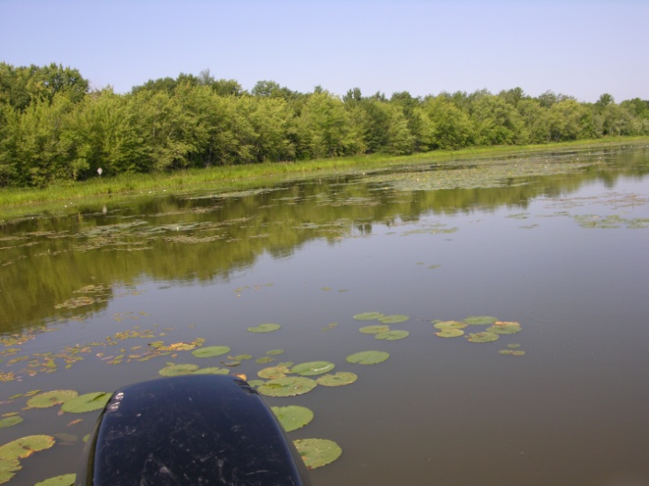
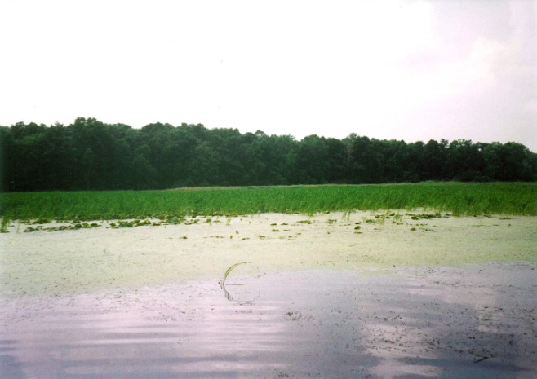
In 2007 the lake failed to produce a harvestable wild rice crop. This was repeated in 2008 with only 210 acres of very sparse rice mapped and assessed. The St. Croix Tribe became concerned at that time that something outside of a normal wild rice “boom-bust” cycle may have been taking place, and communicated this concern with GLIFWC. During the winter of 2008-2009 the Tribe began assessment plans for Clam Lake to determine a.) if the lake would indeed fail to yield a wild rice crop, and b.) if there was a failure what was/were the factors? To make these determinations the St. Croix Tribe facilitated a meeting between the Great Lakes Indian Fish and Wildlife Commission (GLIFWC), the Wisconsin Department of Natural Resources (WI DNR), the Clam Lakes Protection and Rehabilitation District (PRD), Burnett County Land and Water Resources Department, and Short-Elliot-Hendrickson Consulting. The team identified possible limiting factors to wild rice on Clam Lake and proposed a monitoring strategy. Limiting factors included: Climate, disease, pollination issues, water quality, sediment nutrients, herbicides/toxicants, and carp.
2006 Photo of Wild Rice Bed in Lonestar Bay, Clam Lake
2009 Photo of Rice Bed in Lonestar Bay, Clam Lake

Climatic factors were ruled out after looking at regional harvest and productivity data for wild rice. A large scale factor like climate should have affected other similar lakes in the region. Most other waterbodies maintained productivity over the last five years.

Disease and pollination have the ability to completely diminish smaller beds, but should not have so catastrophically affected a waterbody such as Clam that had wild rice so greatly distributed. Instead, these factors may have been limited to small sections of large beds or smaller beds may have been totally lost. Also, no observations of disease or “ghost rice” (empty seed hulls possibly due to non-pollination) were made in the years before or after the crash and no comment relating to this were given in the annual GLIFWC wild rice surveys.

It was then determined that in 2009 the assessment team would focus on looking at water quality, water levels, sediment nutrients, and carp. A whole lake aquatic plant survey was also planned by the Clam Lake Protection and Rehabilitation District as well as a wild rice seed enumeration study and curly leaf pondweed turion (part of the curly-leaf pondweed that overwinters and sprouts in the spring) study. Funding to complete the water quality and sediment nutrients portion of the monitoring was provided by the Wisconsin Tribal Conservation Advisory Council (WTCAC). Two lakes were selected as controls to compare measurement results to. Long Lake, which is hydrologically connected to Clam via a narrow unnamed creek roughly 1 ½ miles in length and Briggs Lake, a small (roughly84 acres) rice producing lake in northern Burnett County. Field as well as lab measurements were taken throughout the summer. These included nitrogen series and sulfates in the sediments, pH, turbidity, secchi, conductivity, dissolved oxygen, oxidation-reduction potential, temperature, and dissolved oxygen. Phosphorous, soluble reactive phosphorous, chlorophyll-a, and phytoplankton measurements were also taken on Clam Lake as part of an ongoing water quality program. Results of the study showed reduced water quality on Clam Lake, but still within tolerable limits for wild rice according to work done by Pillsbury (Pillsbury, 2004).

In the spring of 2009 it was evident that there would be another failure of the rice crop after completing floating leaf surveys. Only 84 acres of sparse rice were mapped and the ricing season was closed for a third consecutive year.

Four separate surveys were commissioned by the Clam Lakes PRD; one being a whole lake aquatic vegetation point-intercept survey to determine species composition and distribution, curly-leaf pondweed bed mapping and turion (reproductive structure of curly leaf pondweed) survey, and a wild rice seed enumeration survey.

Results of the point-intercept vegetation survey showed that almost the entire basin of Upper Clam Lake could be considered littoral zone habitat, but vegetation was found at only 33% of Upper Clam and 21% of Lower Clam (Berg, 2009). Traditionally a mechanized weed harvester would have been employed to create navigation channels and reduce the density of curly-leaf pondweed; a non-native invasive submergent aquatic plant. In 2010, 2011, and 2012 the weed harvesters have not been utilized at all. Vegetation that was found at the sampling points looked as though it had either been grazed, possibly by carp, or was a species that was not as palatable to carp, e.g. coontail or floating leaf pondweed. The survey from the curly leaf bed mapping and turion sampling showed similar results. Curly leaf was found at only 4.9% of the 668 points surveyed (Berg, 2009) on Upper Clam, and was present at 66% of the 350 points surveyed on Lower Clam. While historical analytical data does not exist for curly leaf pondweed on Clam Lake, anecdotal information suggests that the density and distribution of curly leaf and all other vegetation has been greatly reduced in recent years.

To assess the condition of the wild rice seed bank in Clam Lake, ponar samples of sediment were extracted from historical rice beds on Clam. Results from these samples were compared to samples taken on Long Lake in areas that had produced healthy stands of wild rice in 2009. After sediment samples were cleaned and sifted, wild rice seeds were divided into two groups: viable and empty hulls. These were then counted. No viable wild rice seeds were found in any of the samples taken on Clam Lake in 2009, while samples taken on Long Lake averaged 169 seeds/m² in areas of light rice growth and 418 seeds/m² in areas of heavy rice growth (Johnson, 2009). This indicates that the seed bank has been so greatly impacted in Clam Lake that it may not be possible to regenerate the wild rice beds even with protection. This also demonstrates that a main food source for many waterfowl species is non-existent on Clam Lake.

In 2009 roughly 300 adult carp were captured of which 140 of these were aged by staff from the Wisconsin DNR-Spooner Office. The aged fish were dominated by a 4 year old age class, which made up 42% of the sample. The next age class was 19 year old fish (9% of the sample); showing a great imbalance in the age structure of the carp on Clam Lake. The dominant 4 year age class coincides quite well with the failure of the wild rice crop on Clam Lake. These carp would have been recruited in 2005 and capable of spawning at 2 years of age in 2007, the first year of the crop failure. This has provided significant insight to a marked change in the Clam Lake ecosystem.

With data collected in 2009, our group hypothesized that carp were indeed the reason for the catastrophic collapse of the wild rice crop on Clam Lake. To test this hypothesis, we designed an exclosure experiment on Clam Lake in three areas with four different treatments at each area with Freshwater Scientific Services LLC. Treatments were as follows: fenced & seeded plot, fenced unseeded plot, unfenced & seeded plot, and unfenced unseeded plot. These were placed in areas that historically contained rice beds and were designed to answer the questions a.) are carp having an indirect or direct effect on wild rice growth and b.) if removed will the rice re-establish itself? Results from this experiment showed a dramatic difference between the fenced & seeded treatment and the three other treatments at all locations. July wild rice stem counts for wild rice in the treatments showed that the fenced and seeded plots averaged 120/m² (Johnson, 2010). All other plots combined were only able to produce roughly 3 plants total throughout the summer. Other aquatic vegetation also appeared to respond positively to both fenced treatments as well. The unseeded fenced treatment showed the greatest aquatic plant growth which is likely due to the suppression of aquatics by heavy wild rice growth in the fenced and seeded plot. Findings suggest that carp are having a severe direct effect on wild rice in Clam Lake and that the wild rice seed bank on the lake may not be sufficient to self perpetuate. Therefore it is all the more critical to protect the remaining sparse stands in Clam Lake as a seed source as well as protecting rice in connected Long Lake. Further study of the wild rice seed bank in Clam Lake, Long Lake, and the Clam Flowage corroborated this assessment. This expanded upon the work done in 2009 by adding another waterbody (Clam Flowage) and expanding the number of points on Clam from 13 in 2009 to 50 on both Upper and Lower Clam, on Long from 10 to 18, and adding 8 points to the Clam Flowage, a waterbody 12 miles downstream of Clam Lake on the Clam River. Once again results showed 0 viable seeds found in Clam in all samples, while 80 seeds/m² were found in the Clam flowage and 250/m² were found in Long Lake (Johnson 2010).

To test the possibility of herbicide contamination from an upstream cranberry operation, wild rice seeds from Long Lake were overwintered in a shallow pond. These seeds were then planted in three different containers. One container contained sediment and water from Clam Lake, the other sediment and water from Long Lake, and the third just tap water. Germination rates for both the Long and Clam Lake were 70 and 73% respectively.

Waterfowl surveys were initiated in June of 2010 to document usage of both Long and Clam Lakes. Consultation with the WIDNR showed that the only data for Long or Clam Lakes was overwinter data, and it was not very site specific. We implemented a survey plan to would give us better knowledge of when and how many ducks were using each lake and if there was any disparity between the two due to the loss of wild rice. To do this we conducted three summer brood surveys, 7 fall migratory aerial surveys, and 4 spring migratory aerial surveys. Results showed the number of duck broods and Canada goose broods were greater at Long than at Clam Lake. Fall surveys showed the density of ducks on Long to be greater (1.2/ha) than at Clam (0.7/ha) (Caithamer, 2011). Spring surveys showed a drastic difference between the two lakes. Not surprising, the average number of ducks and geese at Long was 20 and 18 times higher respectively than at Clam (Caithamer, 2011).

Carp population assessment also continued in 2010. 132 carp were captured between May 19 and 20th, 2010. Of the 89 fish aged, 84 or almost 90% of them were age 5 fish, showing that the same year class was dominating the adult carp population.

At this point the Tribe decided to perform a mark and recapture study to develop both a population estimate and a biomass estimate. By developing a biomass estimate we could determine if Clam Lakes carp biomass was under the 100 kg/ha threshold post carp removal. Bajer found that carp biomasses that exceed 100 kg/ha resulted in a 50% decrease in vegetative cover (Bajer, 2009). If we were not under this threshold, we could then plan for another carp removal and recalculate biomass.

To do this 10 adult carp were implanted with high frequency radio tags in October of 2010. This served two purposes. 1.) It allowed us to track carp to their overwintering areas when they were aggregated and easier to net and 2.) it allowed us to determine if carp were leaving Clam Lake to spawn in connected waterbodies that were conducive to recruitment. Bajer has also found that carp have a propensity to travel to interconnected lakes that experience hypoxia events which in turn reduce bluegill (main predator of carp eggs and fry) numbers. No mortality was recorded for carp in which transmitters were implanted. These fish were tracked weekly until the end of October/early November 2010.

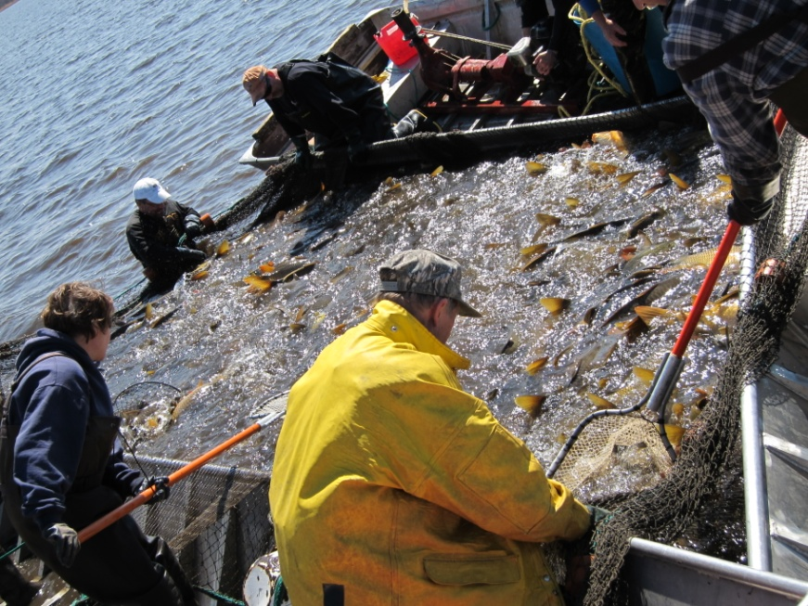
In late October/early November 2010, a series of five open water seine hauls were made to “mark” adult carp in preparation for a recapture event. 1,445 adult carp were captured, marked with a left pectoral fin clip, and immediately released. The ten radio tagged fish were monitored until late January of 2011. When all ten tags were aggregated in a shallow bay of Clam Lake, a commercial fisherman using a 1,500 foot long seine net, attempted to capture the entire group of carp located with telemetry equipment. Unfortunately the net became entangled under the ice and only 54 adult carp were captured. Fish were continuously tracked until April 12, 2011 when another open water seine haul was performed. 2,344 adult carp were captured, of which only 43 were recaps. This resulted in a recapture rate of 1.83%, which was far too low to calculate a confident population estimate. 500 of these fish were marked with a right pelvic fin clip and immediately released, the remaining 1,844 fish were removed from the lake. Between 2011 and 2012 additional fish were marked to bring the marked total to 3,816 individual fish. Over the winter of 2011/2012 roughly 200,000 pounds of carp were removed from Clam Lake using a commercial fishing operation. Data collected during this period allowed us to make a population estimate of roughly 80,000 carp in Clam Lake, showing that we removed approximately a quarter of the population.
Photo of 2011 Carp Marking and Removal

Additionally the St. Croix Tribal Environmental/Natural Resources placed 2 large seine nets; 400 and 450 feet in length to “cutoff” the south bay where the last remaining sparse rice bed exists. This location was chosen due to the fact that a large island sits at the mouth of the bay allowing us to protect 84 acres using only 950 feet of netting. One end of the net is staked on the mainland then run out to the island. Each length of net is anchored using 17 large cinder blocks placed at regular intervals. The intent is that the nets will protect the rice bed from adult carp. Mapping and stem density counts in this location have been completed in 2010, 2011, and will be done in 2012. The map below displays the location of the cutoff nets in relation to the wild rice beds they are intended to protect.
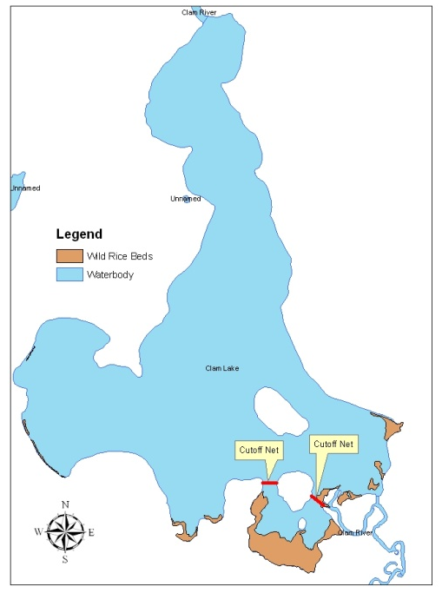
It has also been expressed through the St. Croix tribal elders and rice chief that the spiritual aspect of wild rice cannot be ignored. In addition to the activities proposed here, this group will also be performing ceremonies and feasts to help heal this imbalanced ecosystem. A ceremony was held on the shores of Clam Lake on August 11^{th,} 2011. Rice chiefs, tribal council from St. Croix and other Minnesota and Wisconsin tribes, tribal members, federal and state employees, and community members from Minnesota and Wisconsin attended to talk about the decline of rice on Clam Lake and the regional decline.

Resource Benefit
The aim of this project is to benefit the following species: northern wild rice (a species of primary cultural significance to the St. Croix Chippewa), bluegill, and multiple waterfowl species that use the lake during migration and as residents.

During the 2010-2011 waterfowl surveys on Clam and Long Lakes a total of 10 waterfowl species and 3,416 individual ducks were counted (Caithamer, 2011). In addition, observations of 6 other species were recorded. Species recorded include Canada goose, Trumpeter Swan, Wood Duck, Gadwall, Mallard, Ring Neck, blue-winged teal, bufflehead, hooded merganser, common merganser, great blue heron, scaup, Common loon, double-crested cormorant, American white pelican, and Bald eagle. This project will provide habitat for these species, a number of which are listed in multiple conservation plans. The American White pelican is listed as a species of moderate conservation concern under the Upper Mississippi Valley/Great Lakes Waterbird Conservation Plan. Wood duck, mallard, and blue winged teal are all focal species of the Upper Mississippi Great Lakes Joint Venture. Scaup are the only species showing a decreasing trend according to the 1998 update to the North American Waterfowl Management Plan (NAWMP). They are currently 45% below goal with habitat degradation and loss identified as one of the major reasons for achieving desired recruitment rates. An objective under the NAWMP is to maintain or exceed recent rates of annual increase in all three populations of trumpeter swans to achieve an autumn index of 2,500. The blue winged teal, lesser scaup, and trumpeter swan are all listed as a species of greatest conservation need under the Wisconsin Wildlife Action Plan.

As noted earlier, nearly 300 acres of wild rice could be found growing on both Upper and Lower Clam Lakes in the years prior to 2007. This project will attempt to directly protect 84 acres of wild rice by continuing to place and maintain 950 feet of netting that acts as a barrier for wild rice from the destructive actions of adult carp. This 84 acre protection area will then be used as a seed source to repopulate the remaining 216 acres that have historically supported wild rice growth. In addition to protecting the wild rice we will also be promoting the regeneration of native submergent aquatic plants like clasping leaf pondweed, ribbon leaf pondweed, and common waterweed. Two hundred thirty-seven acres of rice will be monitored on Long, Spencer, Bashaw Lakes and the Clam Flowage. By using radio telemetry to track the movements of carp and continuing annual fish assessments in the Clam River System, we will be proactive in detecting an imbalance in carp populations before they begin to devastate other waterbodies. Data generated from this project will be shared with St. Croix’s partners to help in implementing a region wide monitoring methodology. A statewide wild rice management plan is also currently being drafted, of which work from this project will be included. The research section of the plan identifies carp management as an area where significant research is needed. The Wisconsin All-Bird Conservation Plan lists wild rice habitat as a priority habitat due to its high wildlife value and scarcity. Big Clam Lake is identified as a key site for implementation under this plan and is identified as a site specific restoration priority under the joint Tribal/State Wisconsin Wild Rice Management Draft Plan. Protection of these wild rice beds is also prioritized in the Clam Lake and Lower Clam Sensitive Area Survey Report and Management Guidelines developed by the WI DNR. These wild rice beds are identified as important habitat for bass, panfish, and northern pike as spawning and nursery areas, as well as providing food and habitat for waterfowl, furbearers, reptiles, and amphibians. A report prepared in 2008 for the Minnesota legislature by the Minnesota Department of Natural Resources titled: Natural Wild Rice in Minnesota, states that common carp “lead the way” for invasive species in historical presence and impact on wild rice.

As part of this project, adult carp removal is planned during the winter and young of the year carp in late summer/early fall. The aim is that with removal, combined with other habitat restoration efforts, aquatic vegetation growth will be stimulated to provide habitat and food for young of the year bluegill. Adult carp have been observed in areas where adult bluegills construct nests during spawning. These areas are destroyed by carp spawning activities thus greatly reducing the ability of the bluegill population to recruit. By implementing and assessing habitat restoration efforts we aim to increase the bluegill populations on Clam Lake, a major predator of carp eggs and fry, helping restore balance to the Clam Lake fishery. Ultimately we would like to develop recommendations on bluegill habitat restoration strategies to be used by other agencies who may be attempting to manage systems with a carp imbalance.

The St. Croix Tribe has received funding from the United Sates Fish and Wildlife Service to continue restoration and research efforts on Clam Lake and the Clam River system along with its project partners: The WI DNR, Bureau of Indian Affairs, The Clam Lake PRD, Great Lakes Indian Fish and Wildlife Commission, the University of MN, and the Burnett County Land and Water Resources Dept.

These efforts will include the following objectives:
- Development of adult carp population and biomass estimate
- Carp Removal
- Adult carp location monitoring
- Carp young of the year assessment
- Clam Lake bluegill population assessment
- Wild rice survivability study
- Bluegill habitat restoration
- Protect 84 acres of wild rice habitat
- Seed 10 acres of wild rice habitat/year for 2 years
- Monitor hydrologically connected waterbodies for deleterious effects of common carp

Additional information or questions on this project can be directed towards:

Tony Havranek
Land and Water Resources Manager
St. Croix Tribal Environmental/Natural Resources Department
anthonyh@stcroixtribalcenter.com
(715)349-2195 ext 5183

